**UTM Tutorial Related Links:**

**需要用到的Links:**  
Udemy Course: Advanced Google Analytics 4 Implementation with Tag Manager

<https://www.udemy.com/course/advanced-google-analytics-4/learn/lecture/31605896#overview>

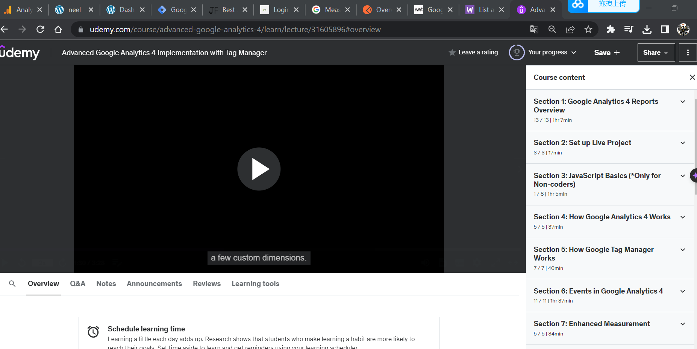

Neel | Google Analytic:

<https://analytics.google.com/analytics/web/?authuser=0#/p395188980/reports/reportinghub?params=_u..nav%3Dmaui>

Neel | Official Website

<http://neel.local/>

Neel | Dashboard

<http://neel.local/wp-admin/>

Google Tag Manager

<https://tagmanager.google.com/#/container/accounts/6132105278/containers/133342640/workspaces/20>

Best JSON Formatter

<https://jsonformatter.org/#google_vignette>

WeatherAPI.com

<https://www.weatherapi.com/login.aspx>

Measure ecommerce  |  Google Analytics 4

<https://developers.google.com/analytics/devguides/collection/ga4/ecommerce?client_type=gtm>

POSTMAN | Overview - GA4

<https://lunar-satellite-941259.postman.co/workspace/26c1ec86-8f21-48e7-8111-df52aa036d95/overview?feature_overview=show>

Google Analytics 4 (GA4) With GTM Support For Magento 2

<https://www.weltpixel.com/google-analytics-4-ga4-with-gtm-support-for-magento-2.html>

WooCommerce REST API

<https://woocommerce.github.io/woocommerce-rest-api-docs/#list-all-products>

**需要用到的Software:**

Local:

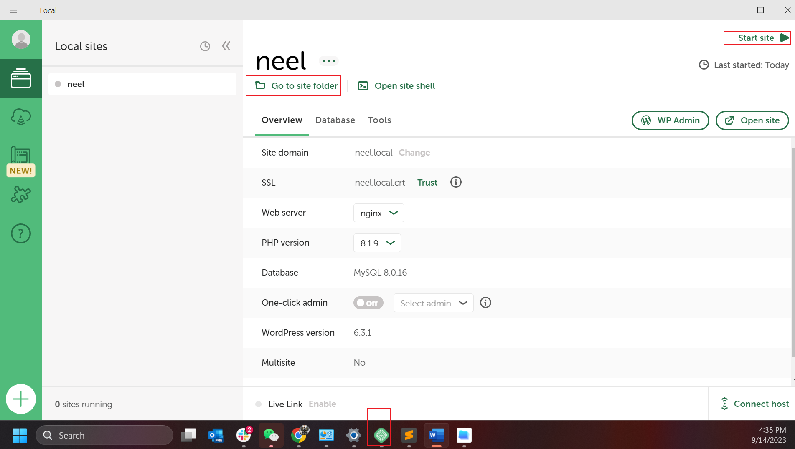

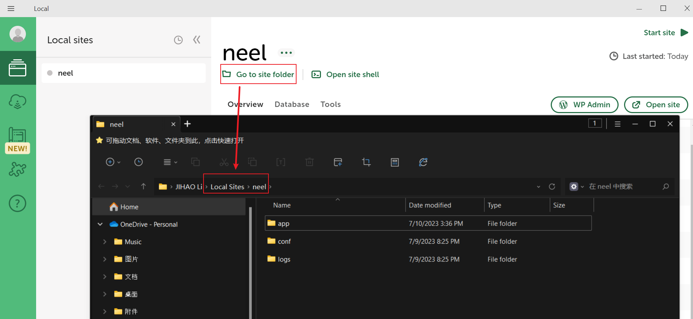

Sublime Text:  
